**Campus Area Network (CAN)**

**A PROJECT REPORT**

***Submitted by***

**VASUDEV JHA 210101120010**

**VASUDEV JHA 210101120010**

**PRAGYA KUMARI 210101120027**

**ANIL RAJ 210101120180**

***in partial fulfilment for the award of the degree of***

**BACHELOR OF TECHNOLOGY**

***in***

**COMPUTER SCIENCE AND ENGINEERING**



**SCHOOL OF ENGINEERING AND TECHNOLOGY**

**PARALAKHEMINDI CAMPUS**

**CENTURION UNIVERSITY OF TECHNOLOGY AND MANAGEMENT**

**ODISHA**

**APRIL 2024**

**DEPARTMENT OF COMPUTER SCIENCE AND ENGINEERING**

**SCHOOL OF ENGINEERING AND TECHNOLOGY**

**PARALAKHEMINDI CAMPUS**

**BONAFIDE CERTIFICATE**

Certified that this project report **Campus Area Network (CAN)** is the bonafide work of “**VASUDEV JHA”** who carried out the project work under my supervision. This is to further certify to the best of my knowledge, that this project has not been carried out earlier in this institute and the university.

**Prof. Jagannath Padhy**

**Professor of Computer Science and Engineering**

*Certified that the above-mentioned project has been duly carried out as per the norms of the college and statutes of the university.*

**Dr. Devendra Maharana**

**HEAD OF THE DEPARTMENT**

**Professor of Computer Science and Engineering**

DEPARTMENT SEAL

**DECLARATION**

I hereby declare that the project entitled “**Campus Area Network (CAN)**” submitted for the “Minor Project” of 5th semester B. Tech in Computer Science and Engineering is my original work and the project has not formed the basis for the award of any Degree / Diploma or any other similar titles in any other University / Institute.

**Name of the Student:** VASUDEV JHA

**Signature of the Student:**

**Registration No:** 210101120010

**Place:** PARALAKHEMINDI

**Date:**

**ACKNOWLEDGEMENTS**

I wish to express my profound and sincere gratitude to Prof. Jagannath Padhy Department of Computer Science and Engineering, SoET, Paralakhemindi Campus, who guided me into the intricacies of this project nonchalantly with matchless magnanimity.

I thank Dr. Debendra Maharana, Head of the Dept. of Department of Computer Science and Engineering, SoET, Paralakhemindi Campus and Dr. Praffula Panda, Dean, School of Engineering and Technology, Paralakhemindi Campus for extending their support during Course of this investigation.

**Name of the Student:** VASUDEV JHA

**Signature of the Student:**

**Registration No:** 210101120010

**Place:** PARALAKHEMINDI

**Date:**

**TABLE OF CONTENTS**

**CHAPTER NO. TITLE PAGE NO.**

**CERTIFICATE** i

**DECLARATION ii**

**ACKNOWLEDGEMENT iii**

**LIST OF TABLES iv- v**

**ABSTRACT vi**

***CHAPTER 1: INTRODUCTION 07-08***

**1.1** Introduction 07

**1.2** Project Statement 08

***CHAPTER 2: PROPOSED METHODOLOGY 09-09***

**2.1** Approach 09

**2.2** Mesh Topology 09

***CHAPTER 3: LITERATURE REVIEW 10-13***

**3.1** Packet Tracer 10

**3.2** Router 10

**3.3** Switch 10

**3.4** Wireless Network 11

**3.5** Server 11

**3.5.1** DNS Server 11

**3.5.2** WEB Server 12

**3.5.3** DHCP Server 12

**3.6** Internet Protocol 12

**3.7** SSH Protocol 13

**3.8** Simulation Environment 13

***CHAPTER 4: PROJECT WORK DONE / CONFIGURATION 14-18***

**4.1** Cisco Packet Tracer Setup 14

**4.2** Network Design (Cabling) 14

**4.3** Router Configuration 15

**4.4** Switch Configuration 16

**4.5** DNSServerConfiguration 17

**4.6** EMAIL ServerConfiguration 18

***CHAPTER 5: RESULTS AND DISCUSSION 19-20***

**5.1** OUTPUT Design 19

**5.2** Connection Check (ping) 20

***CHAPTER 6: CONCLUSIONS AND FUTURE SCOPE 21-22***

**6.1** Conclusion 21

**6.2** Future Scope22

***CHAPTER 7: REFERENCES 23-24***

**ABSTRACT**

Computer networks have a significant impact on the working of an organization. Universities depend on the proper functioning and analysis of their networks for education,administration, communication, e-library, automation, etc.

An efficient network is essential to facilitate the systematic and cost-efficient transfer of information in an organization in the form of messages, files, and resources. The project provides insights into various concepts such as topology design, IP address configuration, and how to send information in the form of packets to the wireless networks of different areas of a Campus.

The aim of this project is to design the topology of the university network using the software Cisco Packet Tracer with the implementation of wireless networking systems. This campus network consists of the following devices:

1. Router (2911)
2. Router (2811)
3. Switch (3650-24RS)
4. Switches (2960-24TT)
5. DHCP Server
6. Email Server
7. DNS Server
8. Wireless Device (Access Point)
9. PCs
10. Tablet’s

**CHAPTER 1**

**INTRODUCTION**

* 1. **Introduction**

The word “digital” is very significant in today’s world, with an increase in the development of technology the entire world is moving towards the digital era. The educational institution plays an important role in this digitalization; hence the campus should adapt to digital means of networking as well and become a “digital campus”. Going wireless plays an important role in this digitalization. The wireless network makes the connection easy with a reduction in the use of wires or cables. A wired connection makes it difficult to keep track of all the devices and to manage the cable connection, which is not only chaotic but also challenging to handle.

Campus networking via wireless connection becomes an important part of campus life and provides the main way for teachers and students to access educational resources, which gives an important platform to exchange information. As laptops and intelligent terminals are widely used, demand for access to information anytime and anywhere has become more and more urgent, but traditional cable networks cannot meet this requirement. Then wireless network construction becomes necessary and essential. The wireless network is one of the important components of a digital campus and wisdom campus. It provides an efficient way to explore the internet with a mobile terminal for teachers and students regardless of cables and places. This is an important mark of the modern campus as a supplement of a cable network. With the development of network and communication technology, cable networks on a university campus bring much convenience for teaching and research work. But for mobility and flexibility, it has obvious shortcomings. A wireless network can overcome these drawbacks and has been applied to the university campus.

* 1. **Project Statement**

In this mini-project, we defined a simulation of campus networks based on wireless networking. The network is divided into two sets: one for the campus area and the other for the hostel area.

The major aim of this project is to show the wireless connectivity that is used in universities to make the network efficient and mobile at the same time. Mobility is the major concentration of this project. In order to provide equal functionality to all the users (college staff and students), we have added DNS, Email, and DHCP servers for the maximum utilization of resources.

Hence the campus network provides different services such as connecting the user to the internet, data sharing among users (students, teachers, and different university members), accessing different web services for different functionalities, so it needs wireless networking for smooth processing.

**CHAPTER 2**

**PROPOSED METHODOLOGY**

**2.1 Approach**

The initial phase involves gathering requirements from various departments to understand their specific network needs. Factors such as the number of users, devices, bandwidth requirements, and security needs will be considered. This information will be crucial in designing a network that meets the current and future needs of the campus.

Based on the gathered requirements, a network topology will be designed to meet the needs of the campus. A mesh topology will be chosen for its high reliability and redundancy. The network will be segmented using VLANs, with each department having its dedicated VLAN. VLAN trunking protocols will be implemented to enable efficient inter-VLAN communication.

The next step involves configuring VLANs on the switches to segment the network according to departmental requirements. VLAN trunking protocols, such as 802.1Q, will be configured to facilitate communication between VLANs. This will help in improving network efficiency and security.

A dedicated server room will be set up to house essential network services, including DHCP, DNS, and a WEB Server. The server room will be equipped with racks, power backup, and environmental controls to ensure the reliability and availability of services. DHCP services will be configured to assign IP addresses dynamically to devices in each VLAN. DNS services will be configured to resolve hostnames to IP addresses within the network. A WEB Server will be deployed to host departmental websites or applications, ensuring security and accessibility.

**2.2 Mesh Topology**

In a mesh topology, each device is connected to every other device in the network, forming a fully interconnected mesh of links. This topology offers high redundancy and reliability, as there are multiple paths for data to travel between devices. If one link or node fails, data can still be routed through alternative paths, ensuring that the network remains operational. However, this redundancy comes at a cost, as a large number of connections and devices can make the mesh topology expensive and complex to manage. Mesh topologies are often used in scenarios where reliability is critical, such as in mission-critical networks or environments where downtime must be minimized.

**CHAPTER 3**

**LITERATURE REVIEW**

**3.1 Packet Tracer**

Cisco Packet Tracer is a powerful network simulation tool developed by Cisco Systems. It allows users to design, configure, and troubleshoot network topologies in a virtual environment. Packet Tracer provides a range of networking devices, such as routers, switches, wireless devices, and end devices, which can be interconnected to create complex network layouts. Users can configure these devices using a simulated command-line interface (CLI) or a graphical user interface (GUI), allowing them to practice and experiment with various networking concepts and configurations. Packet Tracer also offers simulation capabilities, enabling users to visualize how data flows through the network and troubleshoot connectivity issues. Overall, Cisco Packet Tracer is an invaluable tool for networking students, professionals, and enthusiasts to learn and test networking concepts in a safe and controlled environment.

**3.2 Router**

A router is a networking device that forwards data packets between computer networks. It operates at the network layer (Layer 3) of the OSI model and is responsible for determining the best path for data to travel based on the destination IP address in each packet. Routers are essential components of modern computer networks, including the Internet, as they enable communication between different networks. They use routing tables and routing protocols to make decisions about how to forward packets, taking into account factors such as network congestion, packet priority, and the speed of different paths. Routers can connect multiple networks together, allowing devices on one network to communicate with devices on another network. They also provide network security by implementing features such as access control lists (ACLs) and firewalls to control the flow of data.

**3.3 Switch**

A switch is a networking device that operates at the data link layer (Layer 2) of the OSI model. Its primary function is to forward data packets between devices within the same network. Unlike hubs, which simply broadcast data to all connected devices, switches use MAC addresses to determine the intended recipient of each packet and only forward the packet to the appropriate port. This allows switches to reduce network congestion and improve the overall efficiency of the network. Switches are commonly used in Ethernet networks to connect devices such as computers, printers, and servers. They come in various sizes and configurations, ranging from small desktop switches with a few ports to large enterprise switches with hundreds of ports and advanced features like VLAN support, Quality of Service (QoS) prioritization, and port mirroring for monitoring network traffic.

**3.4 Wireless Network**

A wireless network is a type of computer network that uses wireless data connections between network nodes. It eliminates the need for physical cables, allowing devices to connect to the network using radio waves or infrared signals. Wireless networks are commonly used for mobile devices such as laptops, smartphones, and tablets, as well as for connecting devices in locations where running cables is impractical or impossible. They can provide internet access, file sharing, and printer sharing, among other services. Wireless networks can be classified into several types, including Wireless Local Area Networks (WLANs), which cover a small area such as a home, office, or campus; Wireless Metropolitan Area Networks (WMANs), which cover a larger area such as a city or town; and Wireless Wide Area Networks (WWANs), which cover a broad area such as a country or continent.

**3.5 Server**

A server is a computer or device on a network that manages network resources. It provides services, data, resources, or programs to other computers, known as clients, on the same network. Servers are often dedicated, meaning they are designed to perform specific functions, such as hosting websites, managing email, storing files, or running applications. Servers typically have more processing power, memory, and storage capacity than client devices to handle the demands of multiple clients accessing them simultaneously. They also have specialized software, such as operating systems and server applications, to perform their intended functions. Servers can be categorized based on their roles, such as web servers, email servers, file servers, database servers, and application servers, among others.

**3.5.1 DNS Server**

A DNS (Domain Name System) server is a type of server that translates domain names (e.g., www.example.com) into IP addresses (e.g., 192.168.1.1) that computers use to communicate with each other on a network. When you type a domain name into a web browser, your computer sends a request to a DNS server to resolve the domain name into an IP address. The DNS server then looks up the IP address associated with the domain name in its database and returns the IP address to your computer, allowing it to connect to the requested website or service. DNS servers play a crucial role in the functioning of the internet, as they help users access websites and other online services using easy-to-remember domain names instead of complex IP addresses.

**3.5.2 WEB Server**

A web server is a computer system that stores, processes, and delivers web pages to clients over the internet or an intranet. It uses the HTTP (Hypertext Transfer Protocol) to serve files that form web pages to users in response to their requests, which are forwarded by their computers' HTTP clients. Web servers are essential components of the World Wide Web (WWW) infrastructure, as they enable websites and web applications to be accessible over the internet. They can host static web pages (predefined content) and dynamic web pages (content generated at the time of the request, often using server-side scripting languages like PHP, Python, or Ruby). Common web servers include Apache HTTP Server, Nginx, Microsoft Internet Information Services (IIS), and Google Web Server (GWS).

**3.5.3 DHCP Server**

A DHCP (Dynamic Host Configuration Protocol) server is a network server that automatically assigns IP addresses and other network configuration settings to devices on a network. When a device connects to a network, it sends a request to the DHCP server, which then assigns it a unique IP address from a pool of available addresses. The DHCP server also provides other configuration information, such as the subnet mask, default gateway, and DNS server addresses, which are necessary for the device to communicate on the network. DHCP servers help simplify network administration by centrally managing IP address allocation and ensuring that each device on the network has a valid IP address and correct network configuration.

**3.6 Internet Protocol**

The Internet Protocol (IP) is a fundamental protocol used for communicating data across a network. It is part of the Internet Protocol Suite, which also includes protocols like TCP (Transmission Control Protocol), UDP (User Datagram Protocol), and others. IP provides the basic rules for routing and addressing packets of data so that they can travel across networks and reach their intended destination.

IP operates at the network layer (Layer 3) of the OSI model and is responsible for providing the logical addressing that identifies devices on a network. Each device connected to a network, such as a computer or a router, is assigned a unique IP address, which is used to identify and locate the device in the network.

IP is designed to be a connectionless protocol, meaning that it does not establish a direct connection between the sender and receiver before sending data. Instead, each packet of data is sent independently and can take different paths to reach its destination. This allows IP to be used in a wide range of network environments, from small local networks to the global Internet.

There are two main versions of IP in use today: IPv4 (Internet Protocol version 4) and IPv6 (Internet Protocol version 6). IPv4 is the older version and uses a 32-bit address scheme, allowing for a total of about 4.3 billion unique addresses. IPv6, on the other hand, uses a 128-bit address scheme, which provides a vastly larger number of possible addresses, ensuring that there are enough addresses to support the growing number of devices connected to the Internet.

**3.7 SSH Protocol**

The SSH (Secure Shell) protocol is a cryptographic network protocol that allows secure communication over an unsecured network. SSH is typically used to log into a remote machine and execute commands, but it can also be used for secure file transfer and tunneling other applications.

SSH provides strong encryption and authentication mechanisms, making it resistant to eavesdropping and other attacks. It encrypts all data transmitted between the client and the server, including passwords, making it a secure alternative to older protocols like Telnet, which transmit data in plain text.

SSH operates on port 22 by default and uses public-key cryptography to authenticate the client and server. This means that each party has a public and private key pair, and the server verifies the client's identity using the public key. Once the client is authenticated, a secure channel is established for communication.

Overall, SSH is widely used for secure remote access and administration of systems, as well as for secure file transfers and other applications that require secure communication over a network.

**3.8 Simulation Environment**

Cisco Packet Tracer is a network simulation tool developed by Cisco Systems that allows users to design, configure, and simulate network topologies. It is widely used for teaching, learning, and practicing networking concepts, as it provides a realistic environment for hands-on experience with Cisco devices and network configurations.

Packet Tracer offers a user-friendly interface that allows users to drag and drop devices (such as routers, switches, and PCs) onto a workspace and connect them to create a network topology. Users can then configure these devices using a simulated command-line interface (CLI) or a graphical user interface (GUI), similar to how they would configure real Cisco devices.

One of the key features of Packet Tracer is its simulation capabilities, which allow users to simulate the behavior of a network in real-time. Users can test network configurations, troubleshoot connectivity issues, and observe how data flows through the network. Packet Tracer also supports the simulation of network services such as DHCP, DNS, and HTTP, allowing users to practice configuring these services in a safe and controlled environment.

**CHAPTER 4**

**PROJECT WORK DONE / CONFIGURATION**

**4.1 Cisco Packet Tracer Setup**

* Launch Cisco Packet Tracer on your computer.
* Create a new project and name it "Basic Network Setup."
* Drag and drop two switch and two PCs onto the workspace.
* Connect one PC using Ethernet cables.
* Configure the PCs with IP addresses in the same subnet as their respective routers (e.g., PC1: 192.168.1.3/24, PC2: 192.168.1.4/24).
* Test connectivity between the PCs by pinging each other's IP addresses.

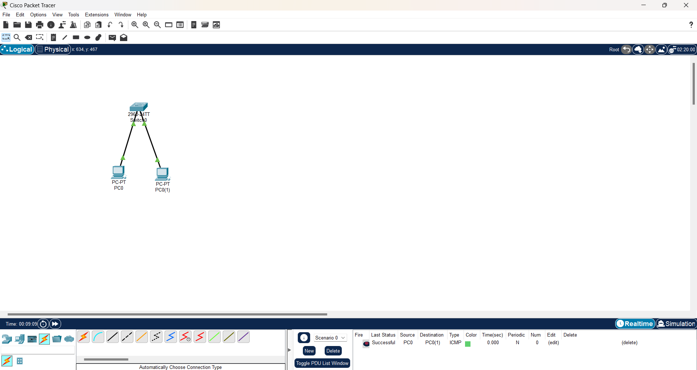

**4.2 Network Design (Cabling)**

* Drag and drop all devices that required for the project.
* Make a group on each device based on requirement.
* Connect all the devices using respective cables.
* Make a frame and give name according to requirement.
* Comment all the IP’s to every VLAN and interface for future configuration.

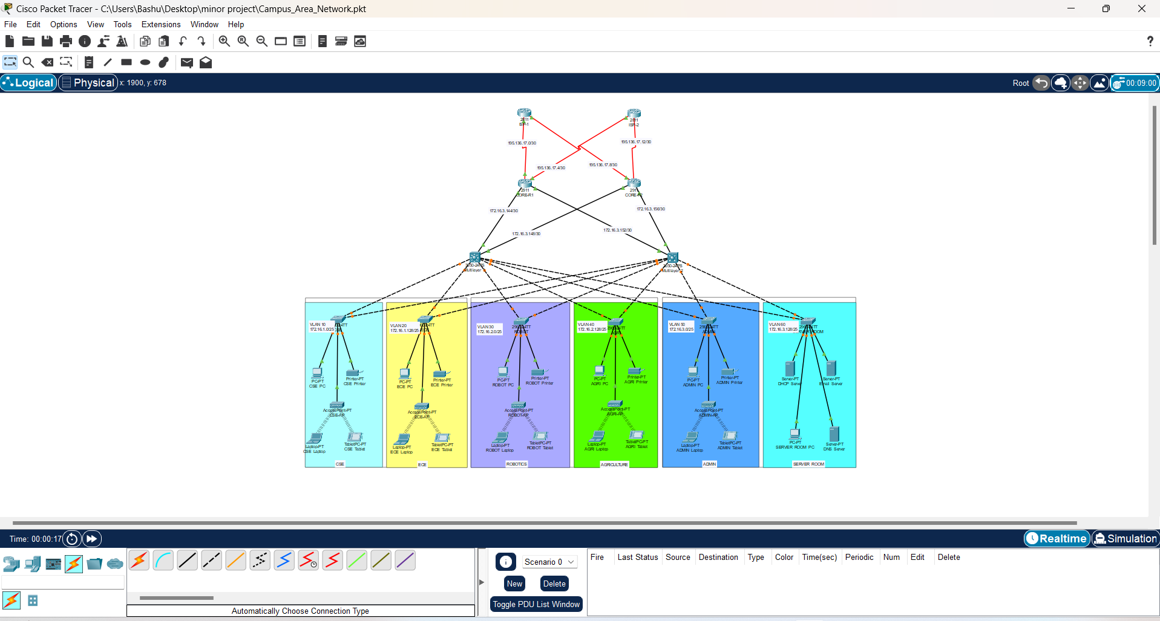

**4.3 Router Configuration**

Router configuration refers to the process of setting up and customizing the settings of a router to ensure proper functioning and security of a network. Here is a basic prompt on configuring a router using the command line interface (CLI):

**Access the Router:** Connect to the router using a console cable or through Telnet/SSH.

**Enter Configuration Mode:** Enter privileged EXEC mode by typing enable and then enter global configuration mode by typing configure terminal.

**Set the Hostname:** Type hostname [name] to set a hostname for the router.

**Configure Interfaces:** Use the interface command to enter interface configuration mode for each interface. Configure IP addresses, subnet masks, and other interface-specific settings.

**Set Up Routing:** Configure static routes using the ip route command or dynamic routing protocols such as OSPF or EIGRP.

**Enable Services:** Enable services like DHCP, NAT, and SNMP as needed.

**Save Configuration:** Type end to exit configuration mode, then copy running-config startup-config to save the configuration to non-volatile memory.

**Verify Configuration:** Use the show running-config command to verify the configuration.

**Exit:** Type exit to exit the router configuration mode.

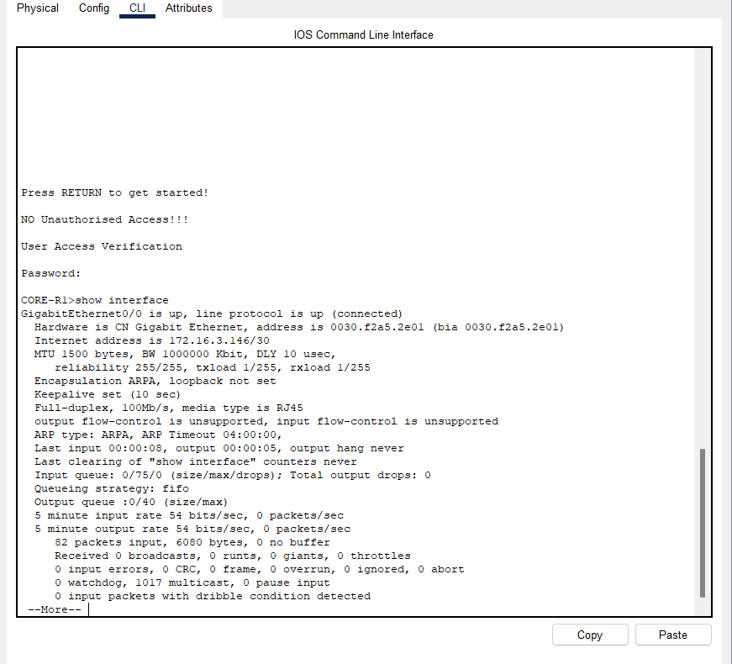

**4.4 Switch Configuration**

Switch configuration involves setting up and customizing the settings of a network switch to ensure proper functioning and security of a network. Here is a basic prompt on configuring a switch using the command line interface (CLI):

**Access the Switch:** Connect to the switch using a console cable or through Telnet/SSH.

**Enter Configuration Mode:** Enter privileged EXEC mode by typing enable and then enter global configuration mode by typing configure terminal.

**Set the Hostname:** Type hostname [name] to set a hostname for the switch.

**Configure Interfaces:** Use the interface command to enter interface configuration mode for each interface. Configure VLANs, IP addresses, and other interface-specific settings.

**Configure VLANs:** Use the vlan command to create VLANs and assign interfaces to VLANs.

**Enable Trunking:** If required, configure trunking on trunk interfaces using the switchport mode trunk command.

**Set Port Security:** Configure port security settings using the switchport port-security command.

**Set Passwords:** Set passwords for privileged EXEC mode, console access, Telnet/SSH, and enable secret.

**Save Configuration:** Type end to exit configuration mode, then copy running-config startup-config to save the configuration to non-volatile memory.

**Verify Configuration:** Use the show running-config command to verify the configuration.

**Exit:** Type exit to exit the switch configuration mode.

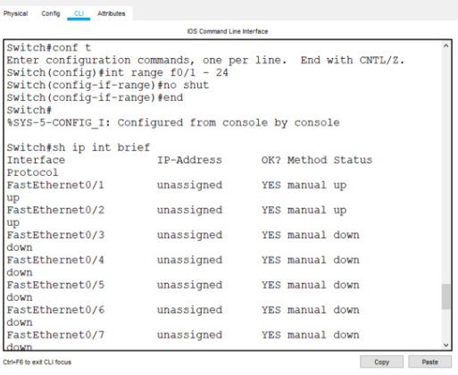

**4.5 DNS Server Configuration**

In Cisco Packet Tracer, you can configure a DNS server using the Cisco ISR (Integrated Services Router) device. Here is a basic prompt on configuring a DNS server on a Cisco ISR using the CLI:

**Access the Router:** Connect to the router using the CLI or console cable.

**Enter Configuration Mode:** Enter privileged EXEC mode by typing enable and then enter global configuration mode by typing configure terminal.

**Configure DNS Server:** Use the following commands to configure the DNS server:

ip dns server

ip domain-lookup

ip domain-name example.com

ip name-server 8.8.8.8

The ip dns server command enables the DNS server functionality on the router.

The ip domain-lookup command enables DNS lookups on the router.

The ip domain-name command specifies the domain name for the router (replace example.com with your domain).

The ip name-server command specifies the IP address of the DNS server to use for domain name resolution (in this example, Google's public DNS server 8.8.8.8 is used).

**Save Configuration:** Type end to exit configuration mode, then copy running-config startup-config to save the configuration to non-volatile memory.

**Verify Configuration:** Use the show running-config command to verify the DNS server configuration.

**Exit:** Type exit to exit the router configuration mode.

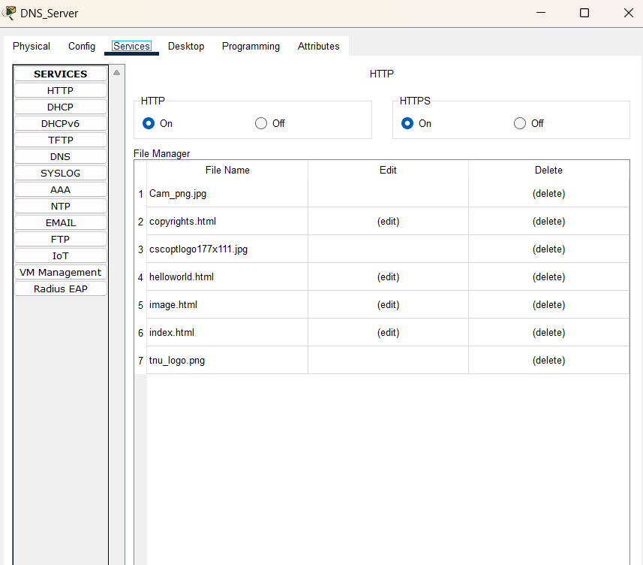

**4.6 EMAIL Server Configuration**

Configuring an email server in Cisco Packet Tracer involves setting up SMTP (Simple Mail Transfer Protocol) and POP3 (Post Office Protocol version 3) services on a router or a server device. Here is a basic prompt on configuring an email server using the CLI on a Cisco ISR (Integrated Services Router) device in Packet Tracer:

**Access the Router:** Connect to the router using the CLI or console cable.

**Enter Configuration Mode:** Enter privileged EXEC mode by typing enable and then enter global configuration mode by typing configure terminal.

**Configure SMTP Server:** Use the following commands to configure the SMTP server:

smtp-server

This command enables the SMTP server functionality on the router.

**Configure POP3 Server:** Use the following commands to configure the POP3 server:

ip pop3 server

This command enables the POP3 server functionality on the router.

**Set Up Email Accounts:** Use the following command to create an email account (replace <username> and <password> with your desired username and password):

php

Copy code

username <username> password <password>

**Save Configuration:** Type end to exit configuration mode, then copy running-config startup-config to save the configuration to non-volatile memory.

**Verify Configuration:** Use the show running-config command to verify the SMTP and POP3 server configuration.

**Access Email Client:** Configure an email client on a device connected to the router's network to send and receive emails using the router's IP address as the SMTP and POP3 server address.

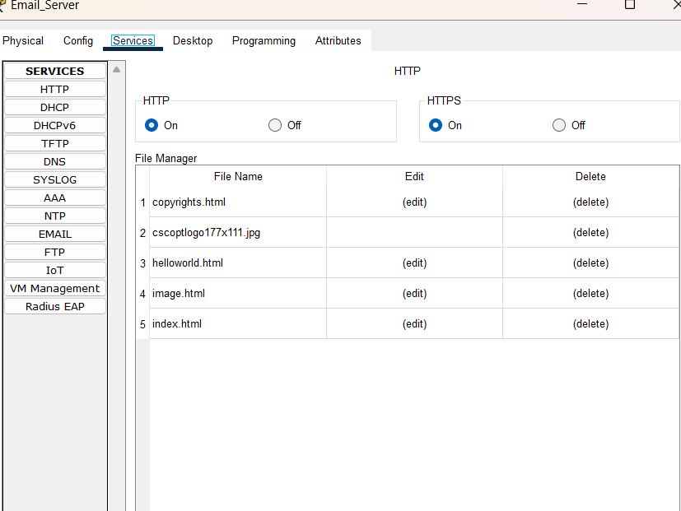

**CHAPTER 4**

**RESULTS AND DISCUSSION**

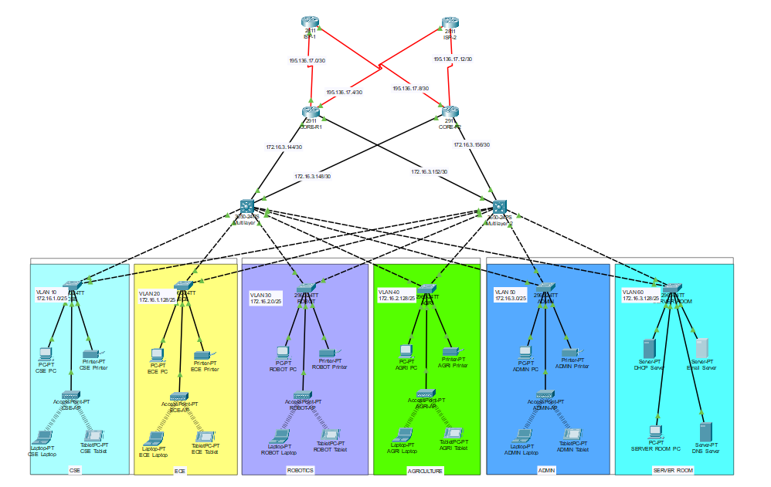**5.1 OUTPUT Design**

**5.2 Connection Check (ping)**

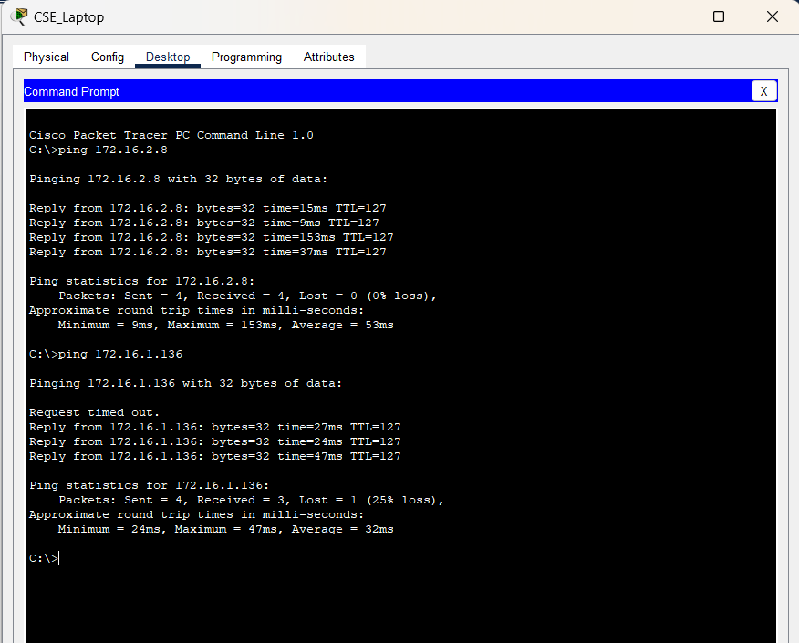

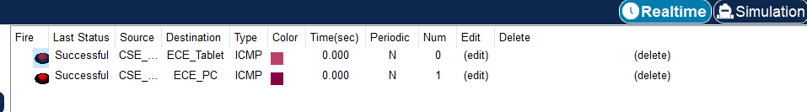

**CHAPTER 6**

**CONCLUSIONS AND FUTURE SCOPE**

**6.1 Conclusion**

Concluding the entire project, it can be seen that the design and configuration of a Campus Area Network (CAN) using Cisco Packet Tracer involves several key components and considerations. The project aimed to create a network infrastructure that catered to the specific requirements of different departments within a college, including dedicated VLANs, a server room with DHCP, DNS, and a WEB Server, and using a mesh topology for connectivity.

Through the design and implementation process, various networking concepts and technologies were applied. VLANs were used to logically segment the network, ensuring that each department had its own isolated network for security and performance reasons. The server room was configured to provide essential services such as DHCP for automatic IP address assignment, DNS for domain name resolution, and a WEB Server for hosting web applications and content.

The use of a mesh topology in the CAN design provided redundancy and resilience, ensuring that even if one link or node failed, communication could still be established through alternate paths. This topology is particularly suitable for environments where reliability and fault tolerance are critical, such as in a college campus setting.

Overall, the project demonstrated the practical application of networking principles and technologies in designing a robust and efficient network infrastructure. By carefully planning and implementing the network design, it was possible to create a reliable and secure network that met the specific requirements of the college's departments.

**6.2 Future Scope**

The project lays a strong foundation for future enhancements and expansions in the college network. Some potential areas for future scope include:

**Advanced Security Measures:** Implementing more advanced security measures such as intrusion detection and prevention systems (IDPS), network access control (NAC), and security information and event management (SIEM) solutions to further enhance network security.

**IPv6 Implementation:** As the demand for IP addresses continues to grow, transitioning to IPv6 would be beneficial. IPv6 offers a larger address space and improved security features compared to IPv4.

**Quality of Service (QoS) Implementation:** Implementing QoS mechanisms to prioritize network traffic and ensure that critical applications receive the necessary bandwidth and latency requirements.

**Wireless Network Expansion:** Expanding the wireless network infrastructure to provide better coverage and capacity, especially in areas with high user density such as lecture halls and libraries.

**Integration of IoT Devices:** As the Internet of Things (IoT) continues to grow, integrating IoT devices into the network and implementing protocols and security measures to manage these devices securely.

**Software-Defined Networking (SDN):** Exploring the adoption of SDN to simplify network management, improve flexibility, and enable dynamic network provisioning.

**Cloud Services Integration:** Integrating cloud services into the network architecture to provide scalable and cost-effective solutions for storage, computing, and application deployment.

**Network Monitoring and Analytics:** Implementing network monitoring and analytics tools to gain insights into network performance, detect anomalies, and optimize network resources.

By considering these future enhancements, the college can ensure that its network infrastructure remains scalable, secure, and efficient to meet the evolving needs of its students, faculty, and staff.

**CHAPTER 7**

**REFERENCES**

Cisco Packet Tracer Overview:

<https://www.netacad.com/courses/packet-tracer>

Cisco Networking Academy:

<https://www.netacad.com/>

Cisco Networking Solutions:

<https://www.cisco.com/c/en/us/solutions/enterprise-networks/index.html>

Cisco Campus LAN Switches:

<https://www.cisco.com/c/en/us/products/switches/campus-lan-switches/index.html>

Cisco Router Configuration Guide: <https://www.cisco.com/c/en/us/support/docs/routers/3800-series-integrated-services-routers/117552-config-ISR-00.html>

Introduction to VLANs:

<https://www.cisco.com/c/en/us/solutions/small-business/resource-center/networking/what-is-a-vlan.html>

Introduction to DHCP:

<https://www.cisco.com/c/en/us/support/docs/ip/dynamic-address-allocation-resolution/27470-100.html>

Introduction to DNS:

<https://www.cisco.com/c/en/us/support/docs/ip/domain-name-system-dns/15283-dns-qna-00.html>

Introduction to Web Servers: <https://www.cisco.com/c/en/us/solutions/collateral/enterprise/design-zone-smart-business-architecture/sba-webhost-dg.html>

Introduction to SSH:

<https://www.cisco.com/c/en/us/td/docs/ios-xml/ios/sec_usr_ssh/configuration/xe-16-9/sec-usr-ssh-xe-16-9-book/sec-secure-shell.html>

Cisco Networking Academy YouTube Channel:

<https://www.youtube.com/user/Netacad>

Cisco Networking Basics Course:

<https://www.coursera.org/learn/networking-basics>

Cisco Networking Community:

<https://community.cisco.com/t5/networking/ct-p/4461-network-infrastructure>

Cisco Networking Blogs:

<https://blogs.cisco.com/networking>

Cisco Press Books on Networking: <https://www.ciscopress.com/store/browse/6?sort=publicationDate%20desc>

Cisco Learning Network:

<https://learningnetwork.cisco.com/>

Introduction to Network Topologies:

<https://www.geeksforgeeks.org/types-of-network-topology/>

Introduction to Quality of Service (QoS):

<https://www.geeksforgeeks.org/quality-of-service-in-computer-networks/>

Introduction to Software-Defined Networking (SDN): <https://www.geeksforgeeks.org/software-defined-networking-sdn/>

Introduction to Cloud Computing:

<https://www.geeksforgeeks.org/cloud-computing/>

**ASSESSMENT**

**Internal:**

|  |  |  |  |  |
| --- | --- | --- | --- | --- |
| **SL NO** | **RUBRICS** | **FULL MARK** | **MARKS OBTAINED** | **REMARKS** |
| 1 | Understanding the relevance, scope and dimension of the project | 10 |  |  |
| 2 | Methodology | 10 |  |  |
| 3 | Quality of Analysis and Results | 10 |  |  |
| 4 | Interpretations and Conclusions | 10 |  |  |
| 5 | Report | 10 |  |  |
|  | **Total** | **50** |  |  |

**Date: Signature of the Faculty**